Don’t suffer your debt in silence! A meeting to develop a movement to fight back!
You are not a loan!
Come Together to Develop a Strategy to Build a
Movement of Resistance Against Student Debt
Coordinate with New York Strike Debt and Oakland Strike Debt
Sunday April 21
7-9PM
Community Church of Boston
565 Boylston St. Boston 3/F
(right across from Copley Plaza,
use the Green Line Boylston stop)

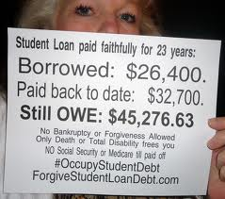
To the financial establishment of the world, we have only one thing to say:
WE OWE
YOU
NOTHING!
Brought to you byand
For more info: http://strikedebt.occupyboston.org strikedebt@occupyboston.orh

